
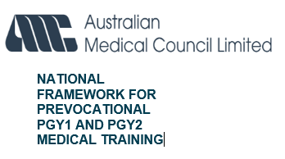
TERM DESCRIPTION TEMPLATE
Term descriptions are designed to provide important information to prevocational trainee medical officers (TMOs) regarding a particular term. They are best regarded as a clinical job description and should contain information regarding the:

- Breadth of clinical experience
- Roles and Responsibilities
- Supervision arrangements
- Contact Details
- Weekly timetable
- Learning outcomes

The term description may be supplemented by additional information such as Clinical Protocols which are term specific. Term supervisors should have considerable input into the content of the term description, and they are responsible for approving the content. In determining learning outcomes, supervisors should refer to the AMC National Framework for Prevocational (PGY1 and PGY2) Medical Training. The term description is a crucial component of orientation to the term, it should also be referred to during the mid-term appraisal and end-of-term assessment processes with the prevocational doctor.

FACILITY:
TERM NAME: |  |  | Ref: VAM -
TERM SPECIALTY:
TERM SUPERVISOR NAME AND POSITION:
CLINICAL TEAM STRUCTURE:  Please identify if the TMO will be allocated to a clinical team or ward for this term.  Include the names and contact details of consultants, registrars, nurses, and other relevant staff on unit. | ☐ Clinical Team Based ☐ Other
 | CONSULTANTS:
 | REGISTRARS:
 | OTHER CLINICAL STAFF (PGY2+, INTERNS):
 | OTHER STAFF (Ward-based, Admin):
ACCREDITED TERM FOR:
 | Number | Term Length  (minimum/maximum duration) | Clinical Patient Care Categories  (Identify 1 or 2 areas of clinical experience to be gained on the term)
PGY1 |  |  | ☐ A – Undifferentiated illness patient care  ☐ B – Chronic illness patient care  ☐ C – Acute and critical illness patient care  ☐ D – Peri-operative/procedural patient care (PGY1 Only)  ☐ Non-direct clinical experience (PGY2 Only)
PGY2+
Is this a service term? Service terms that have discontinuous learning experiences, such as limited access to formal education or regular unit learning activities, less or discontinuous overarching supervision (for example, relief or nights with limited staff). |  |  |  | ☐ YES ☐ NO

OVERVIEW OF UNIT OR SERVICE:
Provide a short overview of the role of the unit, the range of clinical services provided including general information such as bed capacity, casemix and patient catchment area.
Consider indicating any key nursing or allied health disciplines that prevocational doctors may gain value learning from.
REQUIREMENTS FOR COMMENCING THE TERM:
Identify the knowledge or skills required by the TMO before commencing the term and how the term supervisor will determine competency.
If there are separate requirements for PGY1 and PGY2, these must be clearly distinguished.
ORIENTATION:
Detail specific arrangements for orientation to the term. Who is responsible for providing orientation and link resource documents such as clinical policies and guidelines required as reference material for the TMO.
TMOs CLINICAL RESPONSIBILITIES AND TASKS:
Detail the routine duties and clinical responsibilities that the TMOs will be required to undertake during the term, including clinical handover.
CLINICAL EXPERIENCE:
Detail the generalist experience and foundational skills preparing for future practice available, including exposure to clinical care of patients in each of the following (1 or 2 per term):
a) undifferentiated illness patient care
b) chronic illness patient care
c) acute and critical illness patient care
d) peri-procedural patient care
If more than 2 clinical experiences available within the term, please include the main clinical experience/s (maximum of 2) and the secondary clinical experience. Refer to Appendix 1 for Clinical Experience description)
Detail how the term provides clinical opportunities for TMOs to demonstrate knowledge and provide culturally safe and competent clinical practice to Aboriginal and Torres Strait Islander peoples.’
SUPERVISION:  Indicate how the supervision of the TMO is being provided and by whom. To develop competencies required for the sustained care of patients, as well as for episodes of acute care, the TMO must be supervised by a more senior clinician who is responsible for the progress of the patient’s care. The term supervisor must still have sufficient contact with the TMO to assess their progress across the activities of the term.  Please identify staff members with responsibility for TMO supervision and the mechanisms for contacting them, including after hours. | IN HOURS:
 | AFTER HOURS:
LEARNING OUTCOMES:  Detail the knowledge, skills and experience the TMO should expect to acquire during the term. Learning outcomes should be used as a basis of the mid and end-of-term assessments and assists at the beginning of the term to outline expected learning.  The Entrustable Professional Activities (EPAs) that could be assessed should be identified. The Outcome Statements are guided by the identified EPAs.  Pre-requisite learning to be identified (if relevant). | Learning Outcomes:  Please identify a maximum of 5 learning outcomes TMOs should expect to gain on the term and complete the AMC Prevocational Outcome Statements in Appendix 2.  Entrustable Professional Activities (EPAs):  During this term, prevocational doctors should expect to complete the following EPAs. Please refer to Appendix 3 for mapping of outcome statements and EPAs.  ☐ EPA 1 Clinical assessment  ☐ EPA 2 Recognition and care of the acutely unwell patient  ☐ EPA 3 Prescribing  ☐ EPA 4 Team communication – documentation, handover, and referrals
TIMETABLE:
Please indicate the start time and finish times of the shifts the TMO will be rostered to.
The timetable below should be completed to also include term specific and facility wide education opportunities. For example, include TMO education sessions, ward rounds, theatre sessions (where relevant), in-patient time, outpatient clinic, shift handover, morning handover from hospital night team, afternoon handover to hospital’s after-hours team. It is not intended to be a roster but rather a guide to the activities that the TMO should participate in during the week. Examples have been provided below:
 | Monday | Tuesday | Wednesday | Thursday | Friday | Saturday | Sunday
AM | 07.30-08.00  Handover followed by Registrar ward round (meet in Ward 4b) | 07.30-08.00 Handover followed by Registrar ward round (meet in Ward 4b) | 07.30-08.00  Handover from nights  08.00-09.00 multidisciplinary meeting | 07.30-08.00  Handover followed by registrar ward round (meet in Ward 4b) | 07.30-08.00  Handover followed by registrar ward round (meet in Ward 4b) | 07.30-10:30  Handover followed by ward round | 07.30-10:30  Handover followed by ward round
AM | 08.00-09.00  Surgical Forum |  | 09.00-10.00  Consultant ward round (meet in Ward 4b) |  | 08.00-09.00  Unit meeting (2a)
AM | 09.30-11.30  Outpatients |  | 10.00-13.00  Outpatients, Area 1 residents
PM | 13.00-17.00  Pre-admission Clinic (OPD) |  | 12.15-13.30  Intern Tutorial |  | 12:00-13:00  Grand Rounds (protected time)
PM | 14.00-14.30  Registrar paper round | 14.00-14.30  Registrar paper round | 14.00-14.30  Registrar paper round | 14.00-14.30  Registrar paper round | 14.00-14.30  Registrar paper round
PM | 16.30-17.00  End of shift handover | 16.30-17.00  End of shift handover | 16.30-17.00  End of shift handover | 16.30-17.00  End of shift handover | 16.30-17.00  End of shift handover
DESCRIPTION OF UNIT ROSTER (Optional):
E.g.: Monday to Friday 7.30-17.00, 1 Saturday or Sunday every 2 – 3 weeks.
EDUCATION:
Detail education opportunities and resources available to the TMO during the term. Formal education opportunities should also be included in the unit timetable.
Please specify how TMOs are supported on this term to provide culturally safe and competent healthcare to Aboriginal and Torres Strait Islander peoples.
PATIENT LOAD:
Facilities should indicate on average, how many patients a TMO is expected to manage per shift and specify the patient load for the unit.
It is also useful to provide an indication of patient complexity and turnover as this is considered when determining the optimal patient load to support education and training.
OVERTIME: | AVERAGE HOURS PER WEEK:  Average rostered plus unrostered hours
OVERTIME: | ROSTERED HOURS:  Actual hours as per roster
OVERTIME: | UNROSTERED HOURS:  Average additional hours due to unforeseen events
ASSESSMENT AND FEEDBACK:
Detail the formal mid and end-of-term assessment process, using the AMC’s Prevocational Training Term Assessment Form.
ADDITIONAL INFORMATION:
Please include any additional information that the facility considers relevant to the term.
ATTACHMENTS:
Provide links to relevant documents resources (unit orientation, handbooks, protocols, intranet pages. etc).
ENDORSEMENT:
Review/Revised by MEO: Date:
Reviewed by Term Supervisor: Date:
Endorsed by DCT: Date:
Appendix 1: Program Content – Clinical Experience Categories
The term description must identify the one (maximum of two) areas, and the categorisation approved by the prevocational accreditation authority as part of the accreditation of term process. Training providers will allocate prevocational doctors in PGY1 to terms that provide clinical experiences in A–D over the year, and during PGY2, to terms providing clinical experiences in A, B and C. Below provides a description for each of the categories.
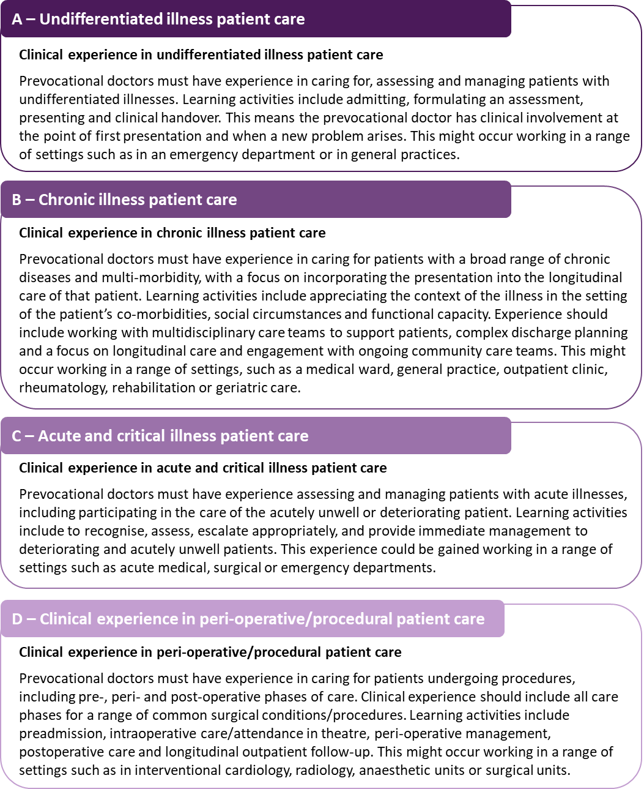
Sourced from the AMCs Training Environment - National Standards and requirements for prevocational (PGY1 and PGY2) training programs and terms.

Appendix 2: AMC Prevocational Outcome Statements
Select the statements that describe the capabilities that prevocational doctors will undertake during the term.
Domain 1: The prevocational doctor as practitioner | Domain 2: The prevocational doctor as a professional and leader | Domain 3: The prevocational doctor as a health advocate | Domain 4: The prevocational doctor as scientist and scholar
☐ 1.1: Place the needs and safety of patients at the centre of the care process, working within statutory and regulatory requirements and guidelines. Demonstrate skills including effective clinical handover, graded assertiveness, delegation and escalation, infection control, and adverse event reporting.  ☐ 1.2: Communicate sensitively and effectively with patients, their family/carers, and health professionals applying the principles of shared–decision making and informed consent.  ☐ 1.3: Demonstrate effective culturally safe interpersonal skills, empathic communication, and respect, within an ethical framework, inclusive of Indigenous knowledges of well-being and health models to support Aboriginal and Torres Strait Islander patient care.  ☐ 1.4: Perform and document patient assessments, incorporating a problem-focused medical history with a relevant physical examination, and generate a valid differential diagnosis and/or summary of the patients’ health and other relevant issues.  ☐ 1.5: Request and accurately interpret common and relevant investigations using evidence-informed knowledge and principles of cost-effectiveness.  ☐ 1.6: Safely perform a range of common procedural skills required for work as a PGY1 or PGY2 doctor.  ☐ 1.7: Make evidence-informed management decisions and referrals using principles of shared decision-making with patients, carers and the health care team.  ☐ 1.8: Prescribe therapies and other products including drugs, fluid, electrolytes, and blood products safely, effectively and economically.  ☐ 1.9: Recognise, assess, communicate and escalate as required, and provide immediate management to deteriorating and critically unwell patients.  ☐ 1.10: Appropriately utilises and adapts to dynamic systems and technology to facilitate practice, including for documentation, communication, information management and supporting decision-making. | ☐ 2.1: Demonstrate ethical behaviours and professional values including integrity; compassion; self-awareness, empathy; patient confidentiality and respect for all.  ☐ 2.2: Identify factors and optimise personal wellbeing and professional practice, including responding to fatigue, and recognising and respecting one's own limitations to mitigate risks associated with professional practice.  ☐ 2.3: Demonstrate lifelong learning behaviours and participate in, and contribute to, teaching and supervision and feedback.  ☐ 2.4: Take increasing responsibility for patient care, while recognising the limits of their expertise and involving other professionals as needed to contribute to patient care.  ☐ 2.5: Respect the roles and expertise of healthcare professionals, learn and work collaboratively as a member of an inter-professional team.  ☐ 2.6: Contribute to safe and supportive work environments, including being aware of professional standards and institutional policies and processes regarding bullying, harassment and discrimination for themselves and others.  ☐ 2.7: Critically evaluate cultural and clinical competencies to improve culturally safe practice and create culturally safe environments for Indigenous communities. Incorporate into the learning plan strategies to address any identified gaps in knowledge, skills, or behaviours that impact Aboriginal and Torres Strait Islander patient care.  ☐ 2.8: Effectively manage time and workload demands, be punctual, | ☐ 3.1: Incorporate disease prevention, appropriate and relevant health promotion and health surveillance into interactions with individual patients. Including screening for common diseases, chronic conditions, and discuss healthcare behaviours with patients.  ☐ 3.2: Apply whole of person care principles to clinical practice, including consideration of a patient’s physical, emotional, social, economic, cultural and spiritual needs and their geographical location. Acknowledging that these factors can influence a patient’s description of symptoms, presentation of illness, healthcare behaviours and access to health services or resources.  ☐ 3.3: Demonstrate culturally safe practice with ongoing critical reflection of health practitioner knowledge, skills, attitudes, practicing behaviours and power differentials in delivering safe, accessible and responsive healthcare free of racism and discrimination.  ☐ 3.4: Demonstrate knowledge of the systemic and clinician biases in the health system that impact on the service delivery for Aboriginal and Torres Strait Islander peoples. This includes understanding current evidence on systemic racism as a determinant of health and how racism maintains health inequity.  ☐ 3.5: Demonstrate knowledge of the ongoing impact of colonisation, intergenerational trauma and racism on the health and wellbeing of Aboriginal and Torres Strait Islander peoples.  ☐ 3.6: Partner with the patient in their healthcare journey, recognising the importance of interaction with and connection to the broader healthcare system. | ☐ 4.1: Consolidate, expand and apply knowledge of the aetiology, pathology, clinical features, natural history and prognosis of common and important presentations in a variety of stages of life and settings.  ☐ 4.2: Access, critically appraise and apply evidence from the medical and scientific literature to clinical and professional practice.  ☐ 4.3: Participate in quality assurance and quality improvement activities such as peer review of performance, clinical audit, risk management and incident reporting and reflective practice.  ☐ 4.4: Demonstrate a knowledge of evidence informed medicine and models of care that support and advance Aboriginal and Torres Strait Islander health.
Appendix 3: Entrustable Professional Activities (EPAs) Behaviours Mapped to the Prevocational (PGY1 and PGY2) Outcome Statements
- A shaded box indicates that the particular outcome is addressed specifically within an EPA.
- +/- indicates that it is possible the outcome will be assessed when the EPA is assessed depending on the individual patient characteristics.
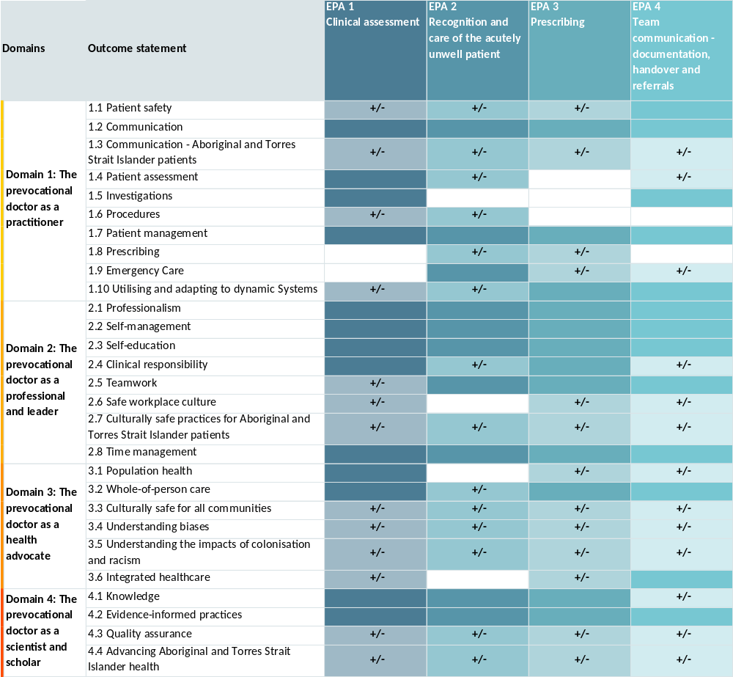
Sourced from the AMCs Training and Assessment Requirements for Prevocational (PGY1 and PGY2) Training Programs.

